**13. User Interface Design**

**MVC Architecture**

MVC = **M**odel **V**iew **C**ontroller

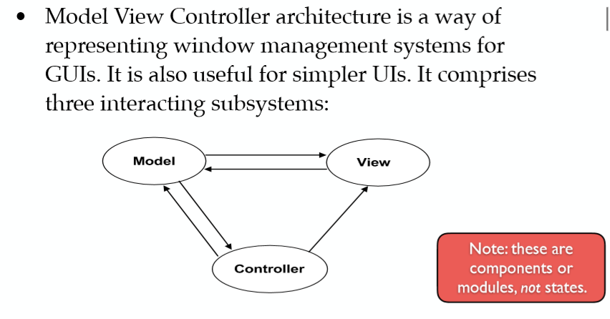

Model = stored info/database – changing display – represents **state** View = information stored in the model subsystem to a graphical display Controller = buttons, external peripherals – represents **events**

**state – diagram**

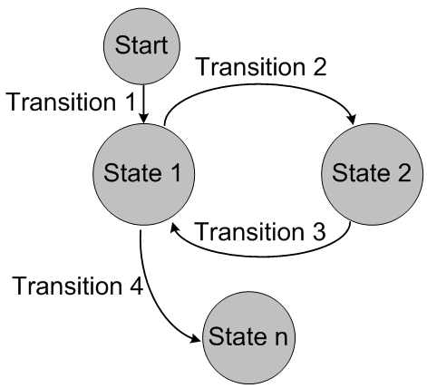

Circles = states, Arrows = events

**Layout - Gestalt Principles**

* Proximity = elements close together are related
* Continuity = aligned objects are related
* Similarity = size/colour/shape are related
* Closure = objects enclosed together are related - boundaries

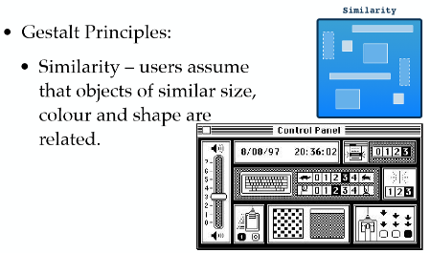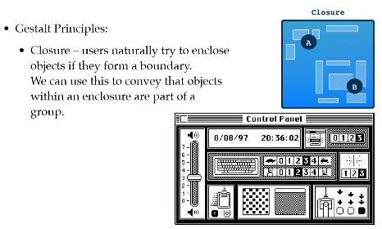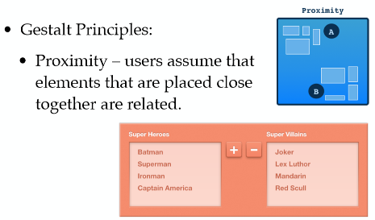

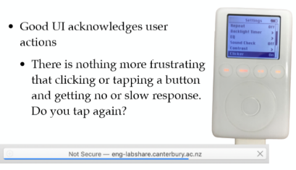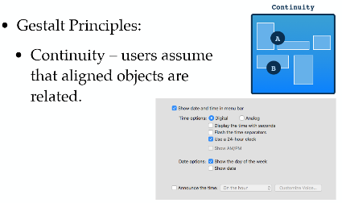

**Navigation**

- sequential steps

- response = clicking action (want to know something has happened)

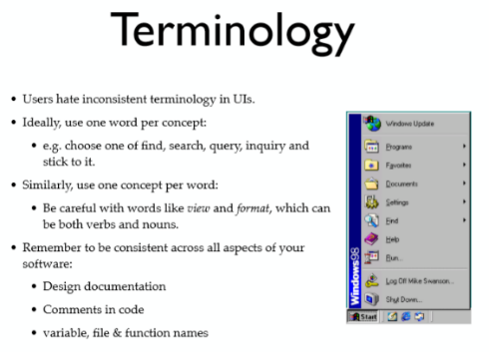Short precise sentences/words e.g describing objects/stuff

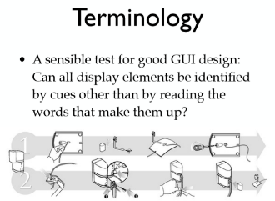Don’t necessarily need instructions to be in words (universally understandable)